




























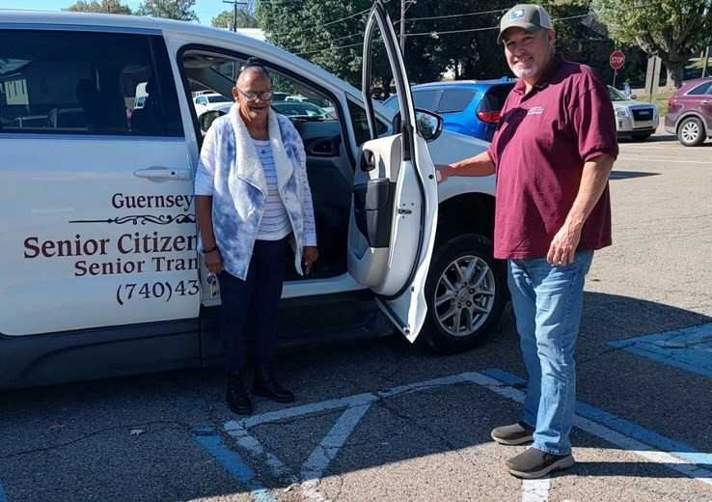

Guernsey County Senior Citizens Center, Inc.
1022 Carlisle Avenue
Cambridge, Ohio 43725
Phone: (740) 432-3838
Fax: (740) 439-7478
TTY: 1-800-750-0750
Toll Free: 1-866-534-2349
Email: transportation@guernseysenior.org Website: www.guernseysenior.org

All drivers are trained in:
Transportation Supervisor
Jodi Brownfield Andy Yandora

DIRECT LINE:
740-432-3838
TRANSPORTATION SERVICES ARE PROVIDED ON A
“DONATION ONLY” BASIS.
· Suggested donation in county one way=$2.00
· Suggested donation Zanesville trips one way= $15.00
· MUST BE 60 YEARS OF AGE OR OLDER
· RESIDENT OF GUERNSEY COUNTY
· HAVE AN ASSESSED NEED FOR TRANSPORT
NEW!!!
ZANESVILLE MEDICAL TRANSPORTATION AVAILABLE!!
CPR
First Aid
Drive Training Defensive Drive Training
And receive yearly DOT physicals

ADA COMPLAINTS
Guernsey County Senior Center Transportation operates in compliance with Title III of the ADA Act. Guernsey County Senior Center Transporta-tion does not discriminate on the basis of disabil-ity. If you feel you have been discriminated
Guernsey County Senior
Citizens Center, Inc.
Senior Transportation Staff
against on the basis of discrimination you may file an ADA discrimination complaint. To file a complaint contact: Shon Gress, Executive Direc-tor at (740)439-6681,Toll free 866-534-2349;
“Serving Guernsey County Seniors”
email sgress@guernseysenior.org or visit our
administrative office at 1022 Carlisle Ave Cam-bridge, OH 43725. For more information, visit www.guernseysenior.org.

TITLE VI
Guernsey County Senior Center operates its programs and services without regard to race,
color, or national origin in accordance with Title VI of the Civil Rights Act. Any person who be-lieves she or he has been aggrieved by any un-lawful discriminatory practice under Title VI or for more information on the civil rights program, or the procedures to file a complaint, contact Shon Gress, Executive Director at (740)439-6681,Toll free 866-534-2349; email
sgress@guernseysenior.org or visit our adminis-trative office at 1022 Carlisle Ave Cambridge, OH 43725. For more information, visit www.guernseysenior.org. Complaints may be filed directly with the FTA with the Office of Civil Rights, Attention: Title VI Program Coor-dinator, East Building, 5th Floor-TCR, 1200 New Jersey Ave., SE Washington, DC, 20590.

REASONABLE MODIFICATIONS
Individuals needing a service accommodation or modification must notify GCSCC Transport of the request when making a reservation. For more infor-mation regarding the reasonable modification policy or how to file a reasonable modification complaint, please contact Garland Harper, Transportation Super-visor at (740)432-3838. Attempts will be made to honor all reasonable modification requests.

Do you need a ride to & from your doctor appointments?

The mission of Guernsey County Senior Citizens Center, Inc.,
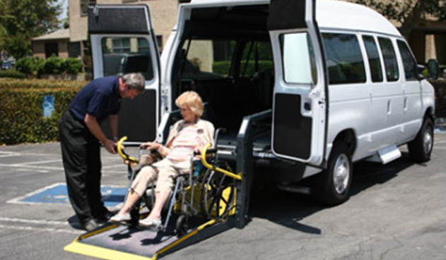
through the services it provides, is to promote the nutritional, physical, emotional, social, and
economic well-being of older adults, and to promote their participation in all aspects of community life.
Guernsey County Senior Citizens Center, Inc. provides prompt & courteous hallway-to-hallway transportation services. We transport senior citizens, age 60 & older, to medical appointments and wellness exams, the grocery store, to run errands, conduct their banking, other shopping, pick-up/ drop-off pharmacy prescriptions, and to many other non-medical transportation locations within Guernsey County, Ohio.
Brochure: August 2025 Edition
Brochure available in Word, Publisher, PDF, on website at: www.GuernseySenior.org Transportation Department
alternative formats are made available upon request.

TRANSPORTATION IS AVAILABLE TO TAKE INDIVIDUALS TO:
Medical Appointments in Zanesville
Grocery Stores Barber Shop/Hair Stylist

Gift Shops Clothing Stores Banks Restaurants Visit a Friend
Church Services Watch Family Ball Games
Doctor Appointments Outdoor Activities Dialysis
And Much More!!!
CALL (740) 432-3838
or TOLL FREE at 1-866-534-2349
FOR TRANSPORTATION



TRANSPORTATION SERVICES ARE PROVIDED ON A
“DONATION ONLY” BASIS.
RECOMMENDED DONATION
$2.00 PER ONE WAY TRIP
$15.00 OUT OF COUNTY ONE WAY

- MUST BE 60 YEARS OF AGE OR OLDER
- RESIDENT OF GUERNSEY COUNTY
- HAVE AN ASSESSED NEED FOR TRANSPORT

HOURS OF OPERATION MONDAY THROUGH FRIDAY 8:00 AM - 6:00 PM
Saturday 8:00-3:00 PM
24-hour advance notice is recommended. Hours and services may be limited based upon fleet availability.

